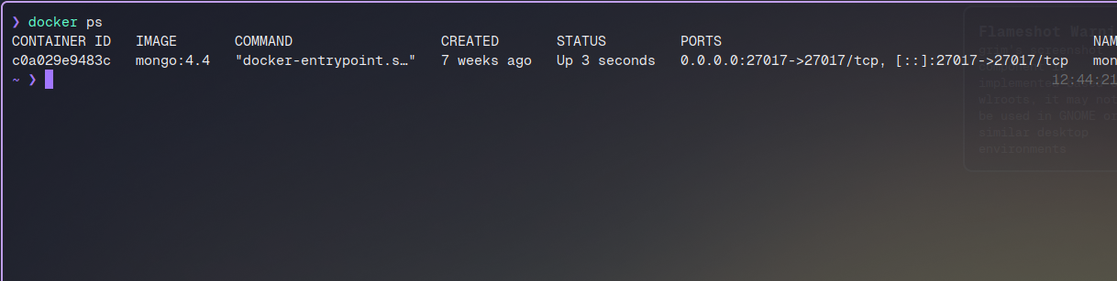
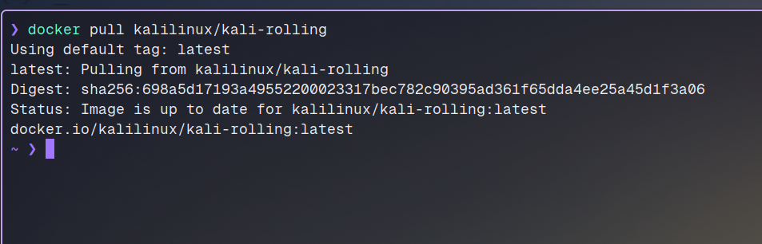
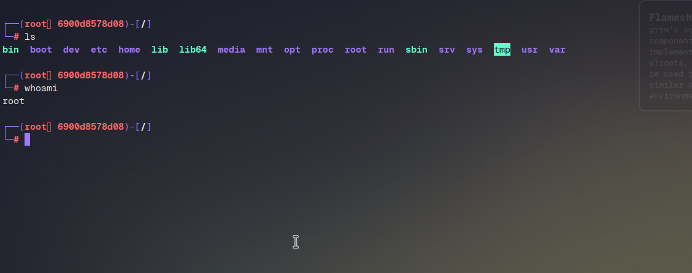
Step :Pulling Kali linux docker container:
Step: Checking out running docker containers:
Running Kali as a container:

Conclusion:
This assignment covered the fundamentals of Docker containerization, including installation, container creation, image management, and persistent storage with volumes. Docker makes application deployment faster, more reliable, and portable across environments. Mastery of Docker is essential for modern DevOps, cloud computing, and microservices architecture.

